2025 CQUMCM
Problem A: Cloud Formation over an Oceanic Island

An oceanic island, an isolated landmass in the vast ocean, serves as a natural laboratory for studying sea-land-atmosphere interactions. Due to the significant difference in heat capacity between seawater and land surfaces (such as sand, vegetation, and rock), unique local circulation systems develop around and over the island under solar radiation. This circulation directly determines the formation, type, location, and evolution of clouds.

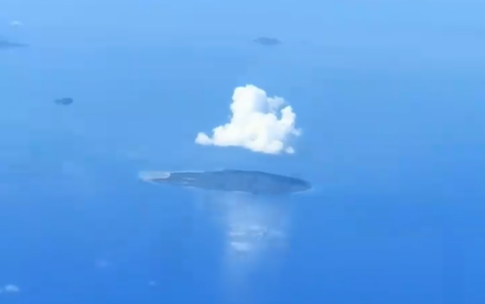

When warm, moist marine air flows towards the island, it is forced to ascend due to factors like topography and surface heating. As the air rises, it expands and cools. When its temperature drops below the dew point, the water vapor it contains condenses into numerous tiny water droplets or ice crystals, forming the clouds we observe. Therefore, clouds over islands are not random occurrences but visible "footprints" of atmospheric dynamic and thermodynamic processes.

Establish a coupled atmospheric thermo-pressure and dynamic model to predict the temporal evolution (e.g., from morning to evening) of macroscopic cloud characteristics—including type, horizontal position, vertical height, and spatial structure—over a specific topographic island, under given conditions of background wind field, sea surface temperature, and atmospheric stratification. Address the following sub-questions:

(1) Assume an unsaturated parcel of marine air is advected towards the island by the background wind. Ignore dynamic lifting, considering only its ascent as a thermal bubble due to heating by the island surface.
a) Model the temperature change of this air parcel with height during adiabatic ascent.
b) Determine the Lift Condensation Level for this air parcel. Analyze the sensitivity of this height to sea surface temperature and relative humidity.

(2) Building upon Question 1, introduce the vertical temperature profile of the ambient atmosphere.
a) Compare the temperature of the rising air parcel with the environmental temperature. Define and calculate key Convective Available Potential Energy indicators to assess whether the atmosphere favors the formation of tall cumulonimbus clouds or flat stratus clouds.
b) Based on your assessment, identify the two most likely basic cloud types under these conditions and describe their general vertical development characteristics.

(3) Consider an idealized elliptical island oriented east-west, with a central mountain range. The background wind is a constant easterly.
a) Establish a two-dimensional steady-state model describing the vertical velocity field resulting from the combination of sea breeze circulation and orographic forcing.
b) Based on the calculated vertical velocity field and the stability analysis from Question 2, predict the island region most likely to experience initial cloud formation and describe the approximate horizontal distribution pattern of the clouds.

(4) Extend the model to three dimensions and introduce a temporal dimension to simulate the process from sunrise to afternoon.
a) How does surface temperature, as a function of solar radiation and surface type, evolve over time? How does this evolution affect the intensity of thermal uplift?
b) The classic "sea breeze front" model indicates that the convergence zone between the sea breeze and the warmer inland air is a region of strong upward motion. Based on this, predict the most likely offshore distance for the formation of a cloud line. Additionally, analyze which area(s) of the island might experience a "cloud-free zone" or significantly reduced cloud cover.

(5) Your model ultimately outputs cloud characteristics.
a) Propose a method for validating your model results against satellite cloud images or surface observations.
b) Perform a sensitivity analysis: Discuss how the morphology and distribution of island clouds would be affected if i) the background wind speed doubled, or ii) the sea surface temperature decreased by 2°C due to ocean currents. Does your model predict these changes to be linear or non-linear?

Appendix: Key Physical Processes and Variable Explanations

To construct the model, the following key variables and processes need to be defined:

1. Sea Breeze Circulation: During daytime, land heats faster than the ocean, creating a thermal low-pressure area. Cooler marine air flows towards the land, forming the sea breeze. This flow is the primary mechanism for transporting moisture inland and triggering cloud formation.
2. Oraphic Lifting: When horizontally moving air encounters hills or mountains on the island, it is forced to ascend the windward slope—a dynamic lifting mechanism.
3. Thermal Lifting: Uneven solar heating creates "hot spots," leading to localized updrafts.
4. Condensation Level: The height at which a rising air parcel cools sufficiently to reach saturation, approximately determining cloud base height.
5. Atmospheric Stability: Describes the propensity for vertical air motion. Under stable conditions, vertical motion is suppressed, favoring layer clouds; under unstable conditions, vertical development is enhanced, favoring towering cumuliform clouds.

Your PDF solution of no more than 25 total pages should include:
• One-page Summary Sheet.
• Table of Contents.
• Your complete solution.
• References list.
• AI Use Report (If used does not count toward the 25-page limit.)

Note: There is no specific required minimum page length for a complete MCM submission. You may use up to 25 total pages for all your solution work and any additional information you want to include (for example: drawings, diagrams, calculations, tables). Partial solutions are accepted. We permit the careful use of AI such as ChatGPT, although it is not necessary to create a solution to this problem. If you choose to utilize a generative AI, you must follow the COMAP AI use policy. This will result in an additional AI use report that you must add to the end of your PDF solution file and does not count toward the 25 total page limit for your solution.

